Rugeley Library Chess Club
Chess in Schools and Communities are starting a friendly and fun drop in chess club. All ages and abilities – (beginners and Grandmasters!) welcome. Free!
Thursdays 4-5pm from 5th September 2019

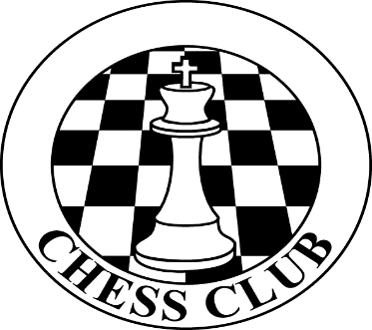

For further information please contact the library staff or r.edgar1453@outlook.com

